***Session 2 HDFS***

***Assignment 2.1***

1. As there was no directory, I have created a directory /user/acadgild/Hadoop

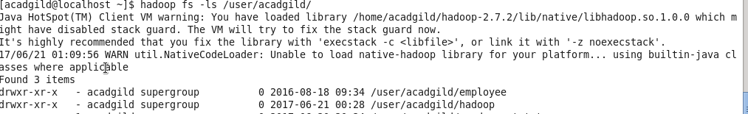

1. Created a file under HDFS directory with name word-count.txt

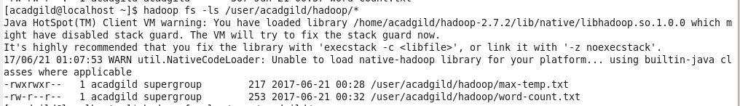

1. I have added few lines to word-count.txt file in local.

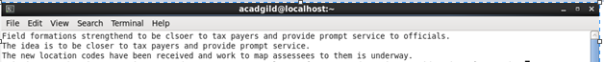

1. I have appended the file , Please find the screenshot below.

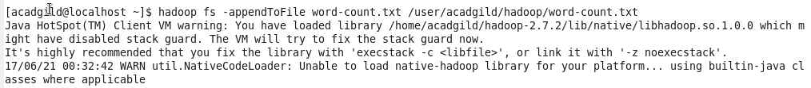

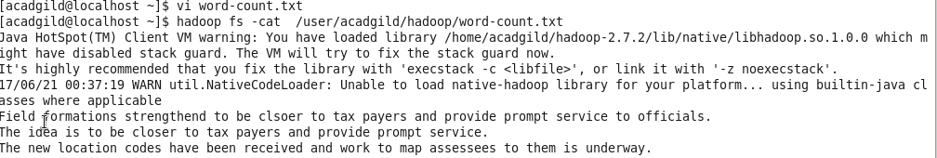

1. I have added one more line to word-count.txt and tried to append it gain.

